# Exercise sheet ERM 11: t-test with dependent samples and repeated measures ANOVA (within subjects design), effect size

1. What is the difference between a „between“ (between subjects) and a “within” (within subjects, repeated measures) experiment? What are advantages and disadvantages of repeated measures?
2. When do you use a t-test for dependent samples and when do you use a repeated measures ANOVA?
3. Think of an experiment in the context of EduTech research, where a t-test for dependent samples would be suited in the analyses. Describe your experiment shortly.
4. What is the effect size and why should you report it? What are advantages compared to the level of significance?
   1. Which test was performed here? Report the result(s) in APA style.

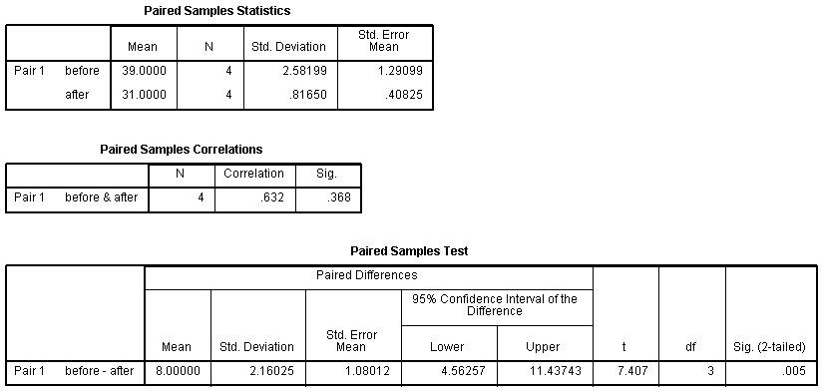

http://www.unt.edu/rss/class/Jon/ISSS_SC/Module008/isss_m8_introttests/node3.html

* 1. Now calculate the effect size (Cohen’s d) from the given information. (You can use an internet calculator)

**Use the data set „Messwiederholung“ (http://quantitative-methoden.de/Downloads_I_A3.htm)**

1. Using a t-test for dependent samples, check if the „number of typed sequences“ is different between measurement 1 and 3 (Messung1 vs Messung3). Report the result(s) including effect size in APA style.
2. Using a repeated measures ANOVA, check if the between subjects factor „gender“ (Geschlecht) affects the „number of typed sequences“ (all three measurement times, Messung1, Messung2, Messung3). Report the result(s) including effect size in APA style.