# Exercise sheet ERM 8: Correlation and chi²

1. What does it mean when two variables *correlate* with each other?
2. Does a correlation imply a causal relationship? Explain and give a fictitious example.
3. Decide for each figure if the correlation between variables is a) negative vs. positive, and b) high vs. low.
4. 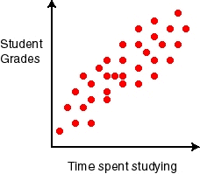

(http://www.mathresources.com/products/insidemath/maa/scatter_plot.html)

1. 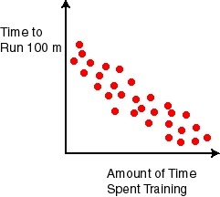

(http://www.mathresources.com/products/insidemath/maa/scatter_plot.html)

1. 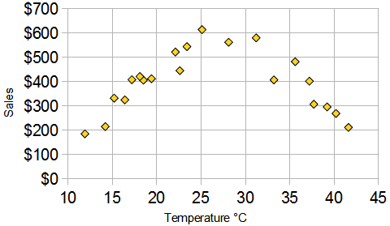

(https://www.mathsisfun.com/data/correlation.html)

1. 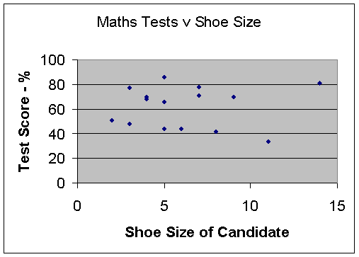

(http://www.mathsmutt.co.uk/files/statbook.htm)

1. 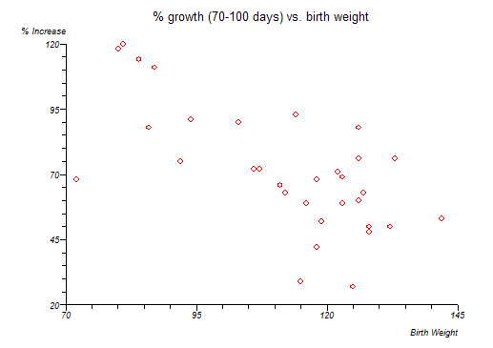

(http://www.statsdirect.com/help/default.htm#regression_and_correlation/regression_and_correlation.htm)

1. You would like to know if there is a relationship between the ability to hold your breath long and the ability to keep your hand in icy water before the pain gets too strong (see table below). Is there such a relationship?

|  |  |  |  |  |  |  |  |  |  |
| --- | --- | --- | --- | --- | --- | --- | --- | --- | --- |
| **Participant** | **A** | **B** | **C** | **D** | **E** | **F** | **G** | **H** | **I** |
| **Holding breath (sec.)** | 60 | 66 | 65 | 67 | 50 | 25 | 98 | 46 | 35 |
| **Holding hand in icy water (sec.)** | 92 | 95 | 85 | 97 | 74 | 22 | 126 | 66 | 60 |

* 1. Input these data first into a scatter plot (draw yourself). Which correlation can you expect?
  2. Then, transfer the data into SPSS and calculate the correlation. Does it match with your expectation?

1. When do you choose a Chi²-Test of independence and when do you calculate a Pearson correlation? Also take into account the scale levels.
   1. Chi²-Test of independence
   2. Pearson Correlation
2. Which assumptions must be met to perform a chi²-Test of Independence?
3. Have a look at the table below. Are the two variables gender and preferred way of taking notes associated? Calculate the p-value in SPSS and report a short conclusion. You will need to enter the data for each participant into SPSS first.

|  |  |  |
| --- | --- | --- |
|  | Pen and Paper | Laptop |
| Male | 16 | 15 |
| Female | 14 | 17 |